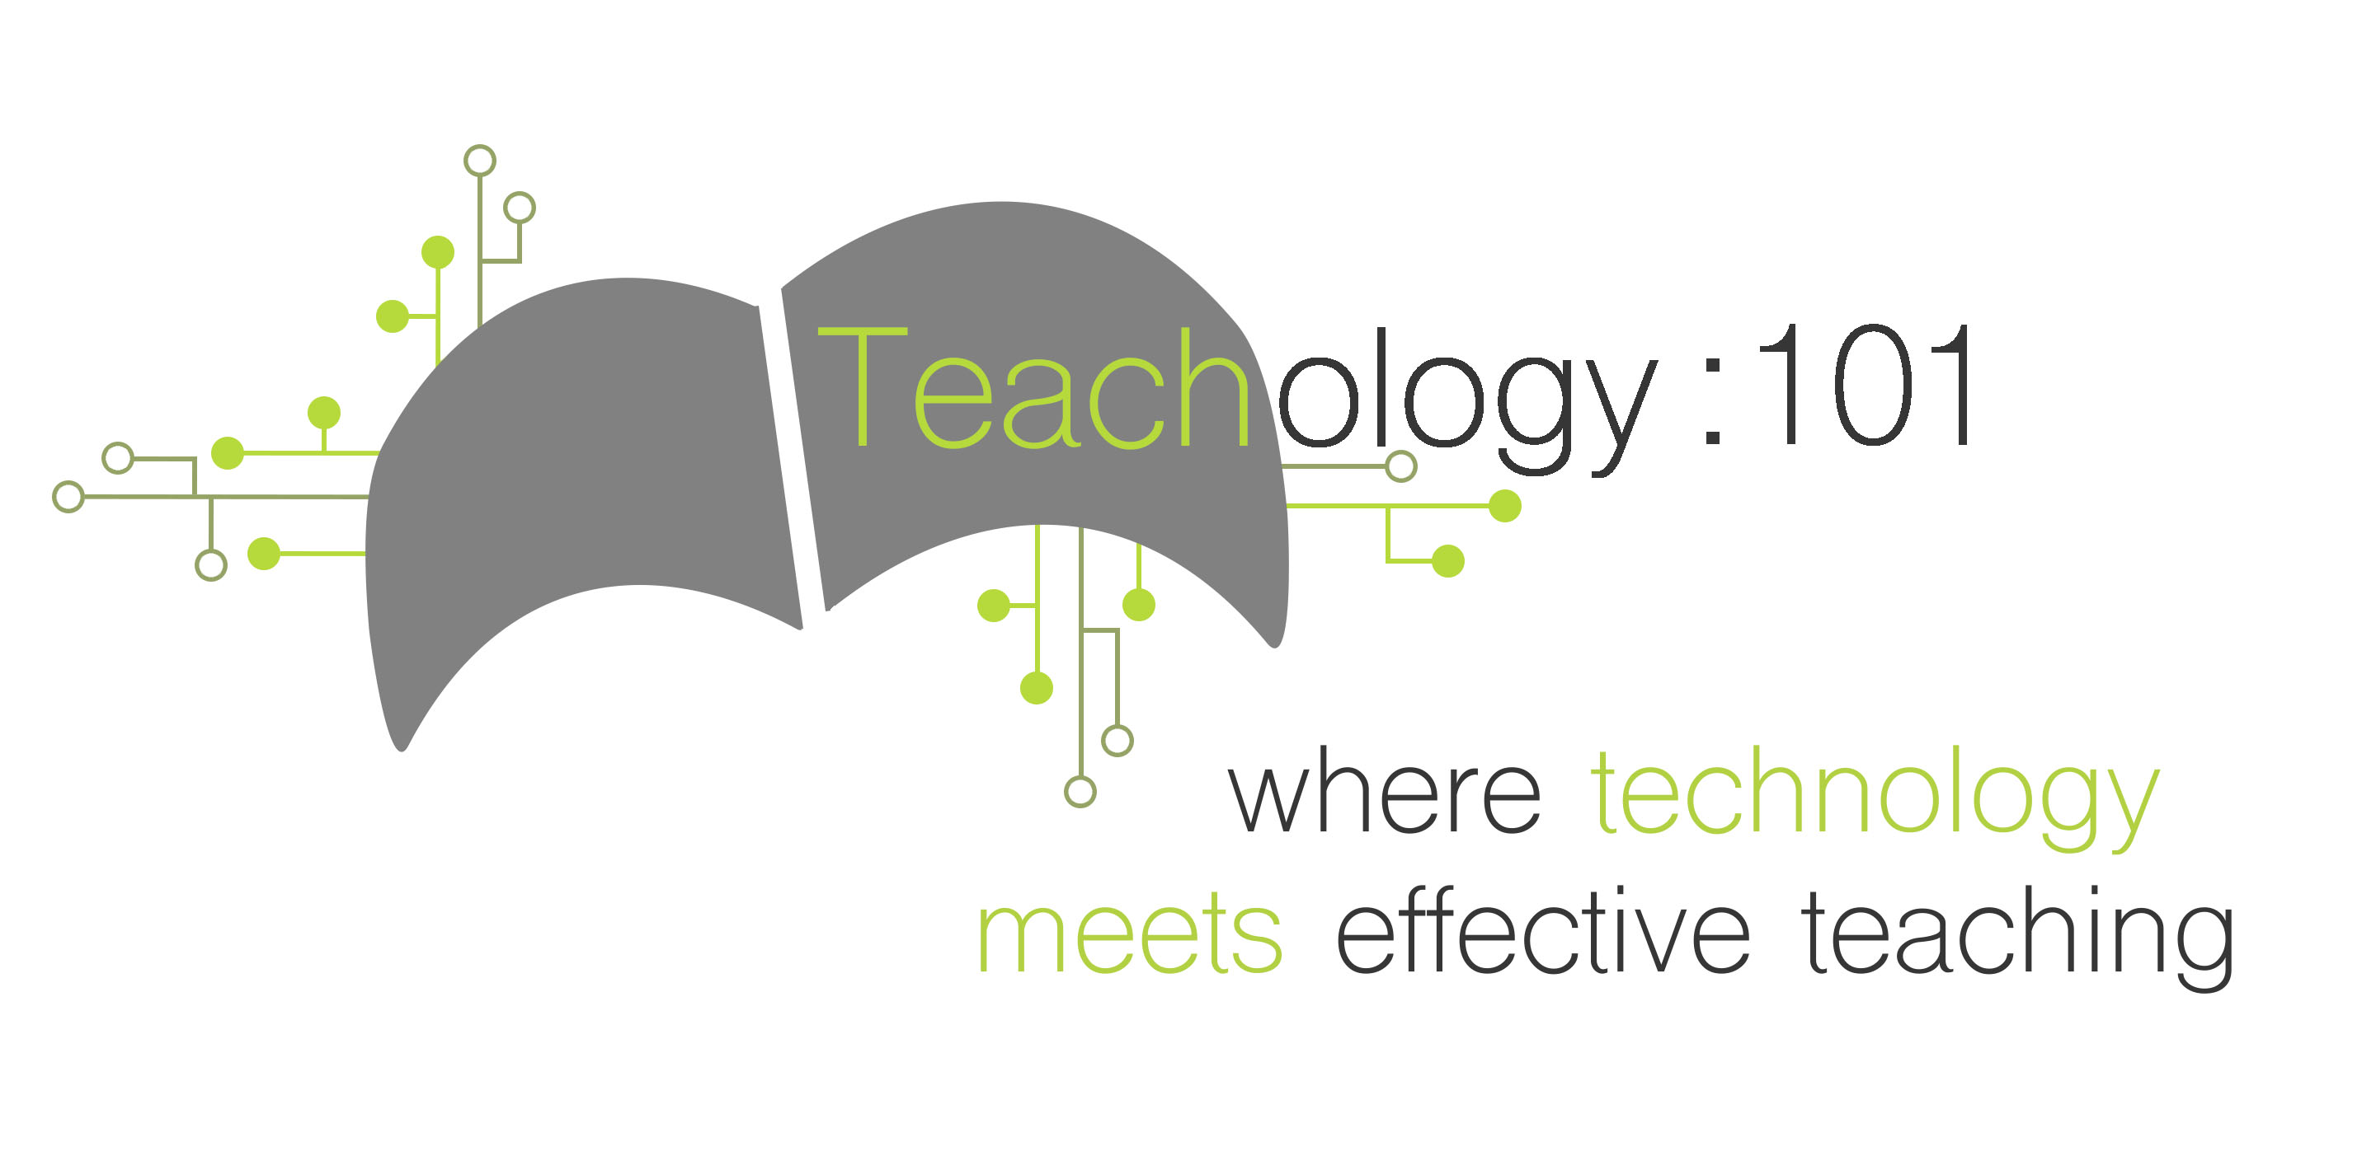

Grades 6-8 Coding Resources

**Scratch** is a web based program designed by the MIT Media Lab in which students learn 21st century skills like thinking creatively, reasoning systematically, and collaborative skills all while learning to code. Students will be able to create share their final project designs with others across the globe.

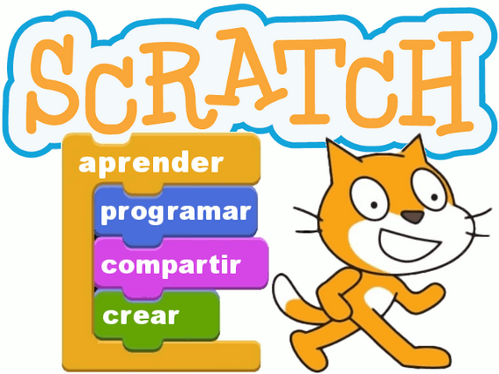



**Tynker** is available on the Ipad and on the web. It provides an online curriculum for teaching students to code with ease in creative project based learning outlets. Tynker provides educators with lesson plans, guides, access to student progress, and standards alignment across content areas.



**Gamestar Mechanic** is an interactive, web based program that teaches students about coding and programming by challenging them to create their own video games. Students can take game design courses, play through other designed games, create their own game and publish it online.

**Hopscotch** is an app that allows students to learn the skills needed for coding and advance through levels in order to create their own coding programming. Students will work through learning the various skills necessary in order to create their own animations and stories.



Visit teach-ology.weebly.com for more great resources on coding!