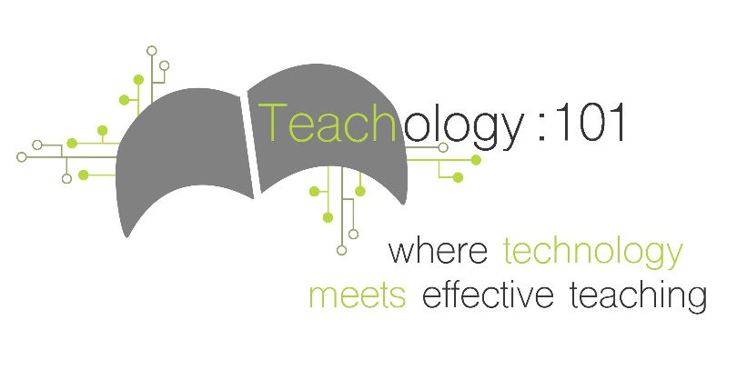

Grades K-5 Coding Resources

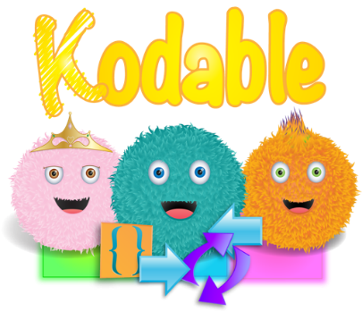

Curriculum for teaching basic computer programming skills. Lessons include direct instruction, group and independent practice activities, and assessment tools. Designed for teachers unfamiliar with coding.

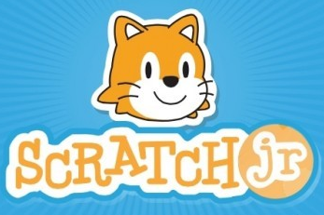

Literacy based program that challenges students to be creative and expressive while learning to code their own stories and games. Scratch Jr. is very interactive and allows students to take ownership over their work!

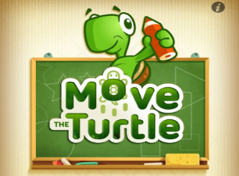

Move the Turtle provides different challenges and tasks that engage students in problem solving and creative expression as they learn the basics of programming. The program is web based and individualized based on students’ progress through the challenges.

For more resources visit teach-ology.weebly.com